Day 16 - 09th July 2025

Task 👍1:

Write an algorithm / steps for selection sort.
- Start with the first element (index 0).
- Assume it is the minimum.
- Compare it with every other element in the unsorted part of the array.
- If you find a smaller element, update the minimum index.
- After checking all elements, swap the minimum element with the first unsorted element.
- Move to the next index and repeat steps 2–5.
- Continue until the entire array is sorted.

For an Example Array: [5, 3, 1, 4])
- Pass 1: Find min from index 0 to 3 → min is 1 → swap with 5 → [1, 3, 5, 4]
- Pass 2: Find min from index 1 to 3 → min is 3 → already in place
- Pass 3: Find min from index 2 to 3 → min is 4 → swap with 5 → [1, 3, 4, 5]
- Done ✅

Task 2:

Write a pseudo code for the selection sort

Selection_Sort(A)
for i = 1 to n - 1
min_j = i
min_x = A[i]

for j = i + 1 to n
if A[j] < min_x then
min_j = j
min_x = A[j]
end if
end for

A[min_j] = A[i]
A[i] = min_x
end for
end procedure

Task 3:

Wap to make sure your list is sorted using selection sort.
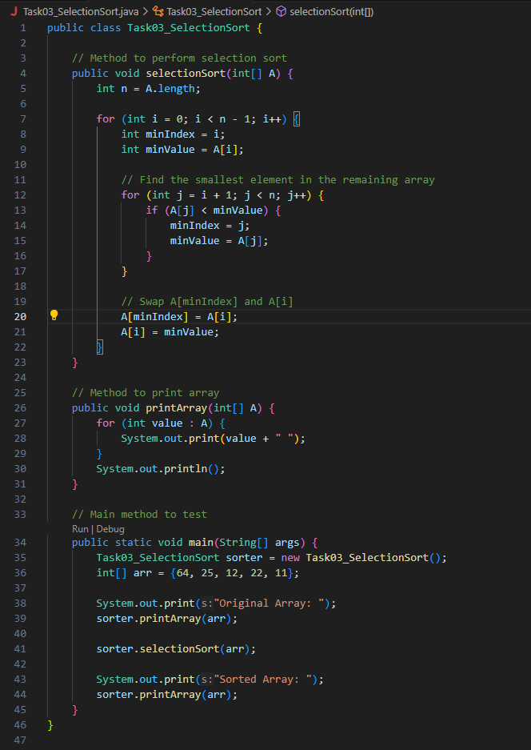

Bubble Sort:

Task 4:

Write an algorithm for the Bubble sort.

- Start with the first element of the array.
- Compare it with the next element.
- If the current element is greater, swap them.
- Move to the next pair and repeat until the end of the array.
- After one full pass, the largest element is at the end.
- Repeat the process for the remaining unsorted part of the array.
- Continue until no more swaps are needed (array is sorted).

Example (Array: [5, 3, 1])
- Pass 1: Compare 5 & 3 → swap → [3, 5, 1] Compare 5 & 1 → swap → [3, 1, 5]
- Pass 2: Compare 3 & 1 → swap → [1, 3, 5]
- Pass 3: No swaps → array is sorted

Task 5:

Write pseudo code for the bubble sort

Bubble_Sort(A)
n ← length of A

for i ← 1 to n - 1
for j ← 1 to n - i
if A[j] > A[j + 1] then
// Swap A[j] and A[j + 1]
temp ← A[j]
A[j] ← A[j + 1]
A[j + 1] ← temp

Task 6:

Wap to make sure your list is sorted using Bubble sort.
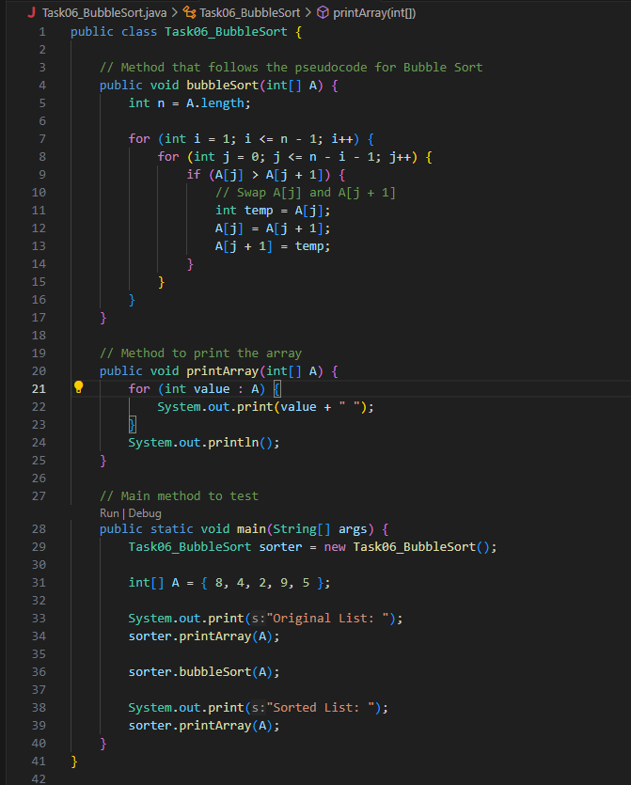

Insertion sort:

Task 7:

Write an algorithm for the Insertion sort.

- Start from the second element (index 1), call it key.
- Compare the key with the elements before it (from right to left).

- While the previous element is greater than key, shift it one position to the right.
- Insert key into its correct position.
- Repeat steps 1–4 for all elements in the array.

Task 8:

Write psedo code for the Insertion sort

INSERTION_SORT(array, n)
for i ← 1 to n - 1 do
key ← array[i]
j ← i - 1

while j ≥ 0 and array[j] > key do
array[j + 1] ← array[j]
j ← j - 1
end while

array[j + 1] ← key

Task 9:

Wap to make sure your list is sorted using Insertion sort.
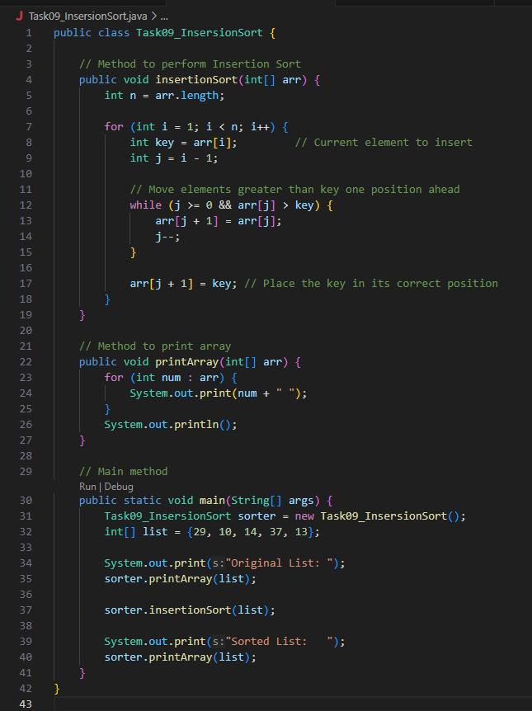

Task 10:

What are the advantages and disadvantages of Bubble sort Algo?
List them

Advantages of Bubble Sort
- Simple to Understand & Implement
Very easy logic — good for beginners and teaching.
- Requires No Extra Space
It’s an in-place sorting algorithm (uses only constant memory).
- Detects Already Sorted List Early (Optimized Version)
Can stop early if no swaps happen in a pass — efficient for nearly sorted data.
- Stable Sort
Maintains the relative order of equal elements.

Disadvantages of Bubble Sort
- Very Slow for Large Data
Time complexity is O(n²), making it inefficient for big lists.
- Inefficient Compared to Other Sorts
Performs worse than Insertion, Merge, or Quick Sort in most cases.
- Many Unnecessary Comparisons and Swaps
Even in nearly sorted data, it performs repeated passes (unless optimized).
- Not Suitable for Performance-Critical Applications
Rarely used in real-world software due to poor performance.
Task 11:
Write algorithm for the merge sort
Merge Sort is a classic divide-and-conquer algorithm. It works by:
- Dividing the array into two halves
- Recursively sorting each half
- Merging the two sorted halves into one sorted array
MERGE_SORT(array, left, right)
if left < right then
mid ← (left + right) / 2

// Step 1: Sort the left half
MERGE_SORT(array, left, mid)

// Step 2: Sort the right half
MERGE_SORT(array, mid + 1, right)

// Step 3: Merge the two halves
MERGE(array, left, mid, right)
end if
END

Task 12:

Write pseudo code for the Merge sort

MERGE(array, left, mid, right)
Create temporary arrays L[] and R[]
Copy data from array[left..mid] into L[]
Copy data from array[mid+1..right] into R[]

i ← 0, j ← 0, k ← left

while i < length(L) and j < length(R) do
if L[i] ≤ R[j] then
array[k] ← L[i]
i ← i + 1
else
array[k] ← R[j]
j ← j + 1
end if
k ← k + 1
end while

// Copy any remaining elements of L[]
while i < length(L) do
array[k] ← L[i]
i ← i + 1
k ← k + 1
end while

// Copy any remaining elements of R[]
while j < length(R) do
array[k] ← R[j]
j ← j + 1
k ← k + 1
end while
END

Task13:

code for Merge sort
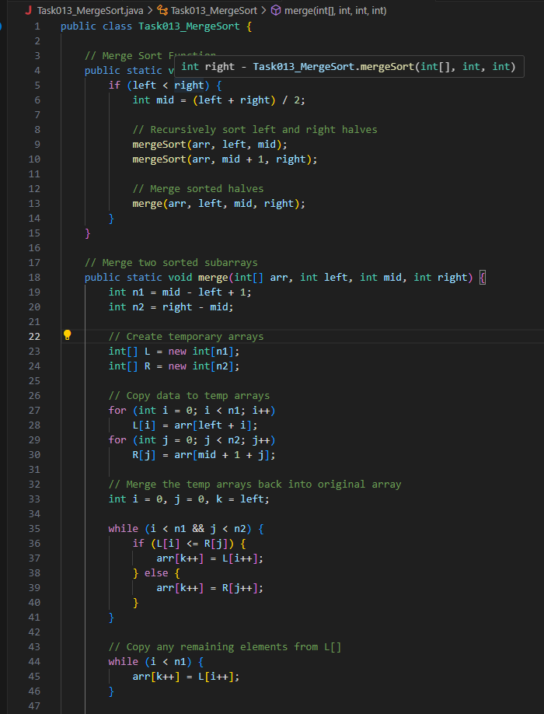
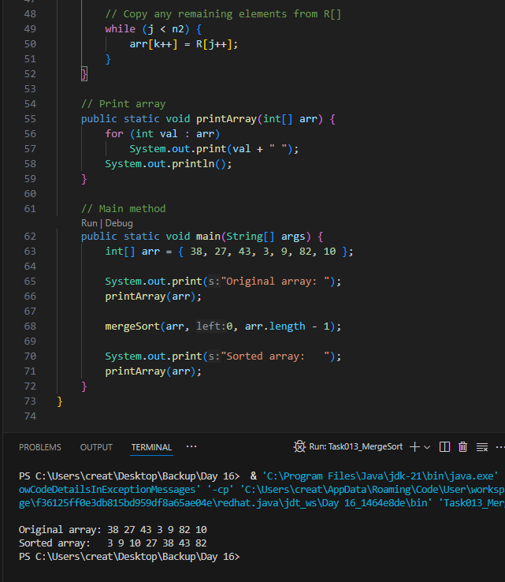

Task 14:

Algo for quick sort

Quick Sort is a divide-and-conquer algorithm that works by:
- Choosing a pivot element.
- Partitioning the array so that:
  - Elements smaller than the pivot go to the left.
  - Elements greater than the pivot go to the right.
- Recursively applying the same logic to the left and right subarrays.

Task 15:

Pseudo code for quick sort

QUICK_SORT(array, low, high)
if low < high then
pivotIndex ← PARTITION(array, low, high)

// Recursively sort elements before and after partition
QUICK_SORT(array, low, pivotIndex - 1)
QUICK_SORT(array, pivotIndex + 1, high)
end if
END

FUNCTION PARTITION(array, low, high)
pivot ← array[high]
i ← low - 1

FOR j ← low TO high - 1 DO
IF array[j] < pivot THEN
i ← i + 1
SWAP array[i] WITH array[j]
END IF
END FOR

SWAP array[i + 1] WITH array[high]
RETURN i + 1 // New pivot index
END FUNCTION

Task 16:

Code for Quick sort
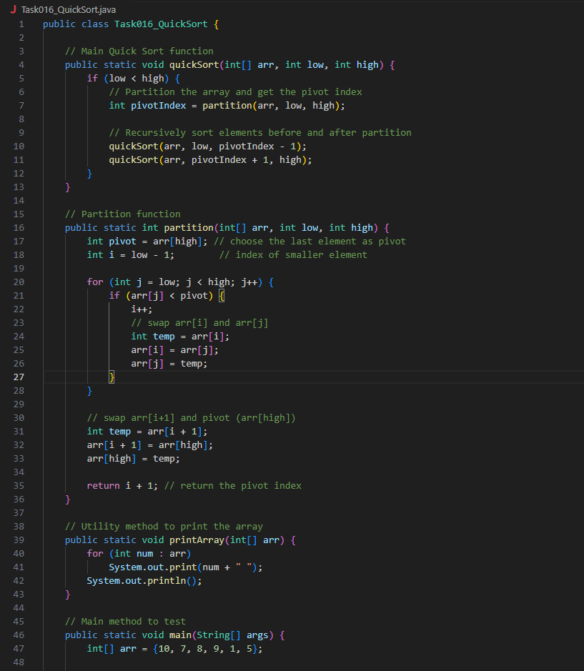

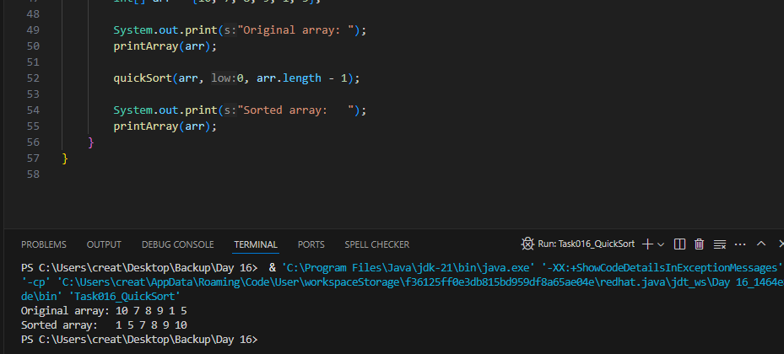
Task 17:

Which one is better merge or bubble in terms of time complexity

Note:
Merge : O(n log n )
Bubble: O (n

Algorithm | Best Case | Average Case | Worst Case
Merge Sort | O(n log n) | O(n log n) | O(n log n)
Bubble Sort | O(n) | O(n²) | O(n²)

Merge Sort is consistently efficient across all cases due to its divide-and-conquer strategy.
Bubble Sort can be fast only when the list is already nearly sorted. But generally, it's sluggish for larger datasets.

Task 18:
Leet code qn:

Find the time complexity of the given merge operation between two sorted array.

Note: O(n + m) as we traverse both arrays once, n and m are size of both the arrays

https://leetcode.com/problems/merge-sorted-array/description/

Task 19:

This code is going overflow of stack.. Can you plz help me fix it guys.. ☹️

public class RecLoop {

public int calc(int n) {
if (n == 0) return 0;
return n + calc(n);
}

psvm(String[] args) {
System.out.println(new RecLoop().calc(10));
}
}

calling calc(n) again with the same value of n, which means:

The base case if (n == 0) is never reached.

The recursion never reduces the problem size.

This leads to infinite recursion.
a stack overflow due to infinite recursive calls.
To fix it we should reduce n in each recursive call:
public int calc(int n) {
if (n == 0) return 0;
return n + calc(n - 1);
}

Task 20:

public class BinarySearchNew {
public int search(int[] arr, int toFind) {
int left = 0, right = arr.len - 1;

while (left <= right) {
int mid = left + (right - left) / 2;

if (arr[mid] == toFind) {
return mid;
} else if (arr[mid] < toFind) {
left = mid + 1;
} else {
right = mid - 1;
}
}
return -1;
}
}

binary search function can we use in unsorted list?

No,binary search requires the array to be sorted in ascending or descending order. If the array is unsorted, the logic breaks down.

Will it give you the correct index no?
No, it won’t give you the correct index if the array is unsorted.
Binary search assumes the array is sorted to decide whether to move left or right based on the comparison. Without that ordering:
- The midpoint logic becomes unreliable.
- It might miss the target even if it exists.
- Worse, it could return a completely wrong index.
In short: Binary search on an unsorted array can lead to incorrect results. Always sort the array first if you want reliable indexing.

